Product Specification
GLSF-1503-FOD(I)
155Mb/s Duplex LC 1550nm DFB-LD 150Km SMF SFP Transceiver
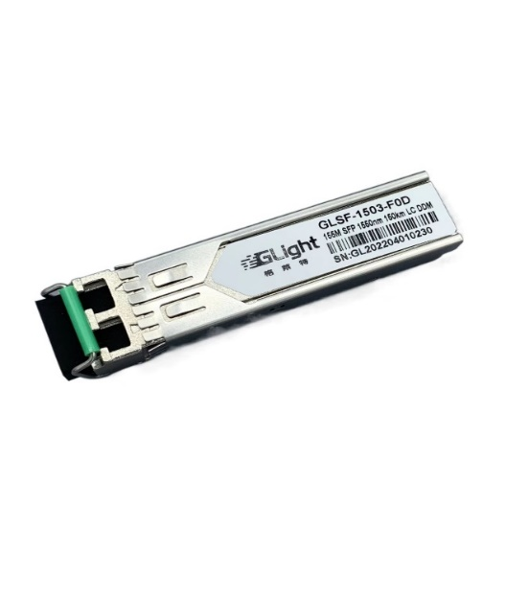
- Features:
- Up to 155Mb/s Data Links
- Hot-Pluggable
- 1550nm DFB laser transmitter
- Duplex LC connector
- Up to 150Km on 9/125μm SMF
- Single +3.3V Power Supply
- Monitoring Interface Compliant with SFF-8472
- Low power dissipation <1.5W typically
- Industrial /Extended/ Commercial operating temperature range: -40°C to 85°C/-5°C to 85°C/-0°C to 70°C Version available
- RoHS compliant and Lead Free

- Applications:
- Fast Ethernet
- SONET OC-3/SDH STM-1
- Other Optical Link

- Applications:
GLight GLSF-1503-FOD(I)Small Form Factor Pluggable (SFP) Transceiver is a high performance, cost effective module which has a Duplex LC optics interface, Standard AC coupled CML for high speed signal and LVTTL control and monitor signals.
The receiver section uses a PIN receiver and the transmitter uses 1550 nm DFB laser, up to 20dB link budge ensure this module SONET OC-3/SDH STM-1 150Km application.

- Absolute Maximum Ratings
Parameter | Symbol | Min. | Typical | Max. | Unit
Storage Temperature | T_{S} | -40 |  | +85 | °C
Supply Voltage | V_{CC} | -0.5 |  | 4 | V
Relative Humidity | RH | 0 |  | 85 | %
- Recommended Operating Environment:
Parameter |  | Symbol | Min. | Typical | Max. | Unit
Case operating Temperature | Industrial | T_{C} | -40 |  | 85 | °C
 | Extended |  | -5 |  | 85
 | Commercial |  | 0 |  | 70
- Electrical Characteristics (T_{OP} = Tc, VCC = 3.135 to 3.465 Volts)
Parameter | Symbol | Min. | Typical | Max. | Unit | Note
Supply Voltage | Vcc | 3.14 | 3.30 | 3.47 | V
Supply Current | Icc |  |  | 300 | mA
Inrush Current | I_{surge} |  |  | Icc+30 | mA
Maximum Power | P_{max} |  |  | 1.0 | W
Transmitter Section:
Input differential impedance | R_{in} | 90 | 100 | 110 |  | 
Single ended data input swing | V_{in PP} | 200 |  | 1200 | mVp-p
Transmit Disable Voltage | V_{D} | Vcc – 1.3 |  | Vcc | V | 2
Transmit Enable Voltage | V_{EN} | Vee |  | Vee+ 0.8 | V
Transmit Disable Assert Time | T_{dessert} |  |  | 10 | us
Receiver Section:
Single ended data output swing | Vout,pp | 300 |  | 1000 | mv | 3
Data output rise time | t_{r} |  |  | 1300 | ps | 4
Data output fall time | t_{f} |  |  | 1300 | ps | 4
LOS Fault | V_{losfault} | Vcc – 0.5 |  | V_{CC_host} | V | 5
LOS Normal | V_{los norm} | V_{ee} |  | V_{ee}+0.5 | V | 5
Power Supply Rejection | PSR | 100 |  |  | mVpp | 6
Deterministic Jitter Contribution | RXΔDJ |  |  | 51.7 | ps
Total Jitter Contribution | RXΔTJ |  |  | 122.4 | ps

Note:
- AC coupled.
- Or open circuit.
- Into 100 ohm differential termination.
- 20 – 80 %
- LOS is LVTTL. Logic 0 indicates normal operation; logic 1 indicates no signal detected.
- All transceiver specifications are compliant with a power supply sinusoidal modulation of 20 Hz to 1.5MHz up to specified value applied through the power supply filtering network shown on page 23 of the Small Form-factor Pluggable (SFP) Transceiver Multi-Source Agreement (MSA), September 14, 2000.

- Optical Parameters(T_{OP} = Tc, VCC = 3.135 to 3.465 Volts)
Parameter | Symbol | Min. | Typical | Max. | Unit | Note
Transmitter Section:
Center Wavelength | λ_{c} | 1530 | 1550 | 1570 | nm | 1
Spectral Width(RMS) | σ_{RMS} |  |  | 1 | nm
Optical Output Power | P_{out} | 1 |  | 5 | dBm | 2
Optical Rise/Fall Time | t_{r} / t_{f} |  |  | 1300 | ps | 3
Extinction Ratio | ER | 9 |  |  | dB
Relative Intensity Noise | RIN |  |  | -120 | dB/Hz
Deterministic Jitter Contribution | TXΔDJ |  |  | 56.6 | ps
Total Jitter Contribution | TXΔTJ |  |  | 119 | ps
Eye Mask for Optical Output | Compliant with IEEE802.3 z (class 1 laser safety)
Receiver Section:
Optical Input Wavelength | ● | 1530 |  | 1570 | nm
Optical Input Power | Pin | -36 |  | -3 | dBm | 4,5
Receiver Overload | P_{ol} | -3 |  |  | dBm | 4,5
RX Sensitivity | Sen |  |  | -33 | dBm | 4,5
Receiver Reflectance |  | 12 |  |  | dB
RX_LOS Assert | LOS _{A} | -45 |  |  | dBm
RX_LOS Deassert | LOS _{D} |  |  | -36 | dBm
RX_LOS Hysteresis | LOS _{H} | 0.5 | 2 | 2.5 | dB
General Specifications
Data Rate | BR |  | 155 |  | Mb/s
Bit Error Rate | BER |  |  | 10⁻¹²
Max. Supported Link Length on 9/125μm SMF@155M | L_{MAX} |  | 150 |  | km | 6
Total System Budget | LB | 20 |  |  | dB | 7

Note
1. Also specified to meet curves in FC-PI 13.0 Figures 18 and 19, which allow trade-off between wavelength spectral widths.
2. Class 1 Laser Safety per FDA/CDRH and EN (IEC) 60825 regulations.
3. Unfiltered, 20-80%. Complies with IEEE 802.3 (Gig. E), FC 1x and 2x eye masks when filtered.
4. Measured with conformance signals defined in FC-PI 13.0 specifications.
5. Measured with PRBS 231 -1at 10-12 BER
6. Dispersion limited per FC-PI Rev. 13
7. .Attenuation of 1dB/km is used for the link length calculations. Distances are indicative only. Please refer to the Optical Specifications in Table IV to calculate a more accurate link budget based on specific conditions in your application.
- Pin Assignment
Diagram of Host Board Connector Block Pin Numbers and Names

- Pin Description
Pin No | Name | Function | Plug Seq | Notes
1 | VeeT | Transmitter Ground | 1 | 1
2 | TX Fault | Transmitter Fault Indication | 3
3 | TX Disable | Transmitter Disable | 3 | 2
4 | MOD-DEF2 | Module Definition | 2 | 3
5 | MOD-DEF1 | Module Definition 1 | 3 | 3
6 | MOD-DEF0 | Module Definition 0 | 3 | 3
7 | Rate Select | Not Connected | 3 | 4
8 | LOS | Loss of Signal | 3 | 5
9 | VeeR | Receiver Ground | 1 | 1
10 | VeeR | Receiver Ground | 1 | 1
11 | VeeR | Receiver Ground |  | 1
12 | RD- | Inv. Received Data Out | 3 | 6
13 | RD+ | Received Data Out | 3 | 6
14 | VeeR | Receiver Ground | 3 | 1
15 | VccR | Receiver Power | 2 | 1
16 | VccT | Transmitter Power | 2
17 | VeeT | Transmitter Ground | 1
18 | TD+ | Transmit Data In | 3 | 6
19 | TD- | Inv. Transmit In | 3 | 6
20 | VeeT | Transmitter Ground | 1

Notes:
- Circuit ground is internally isolated from chassis ground.
- Laser output disabled on TDIS >2.0V or open, enabled on TDIS <0.8V.
- Should be pulled up with 4.7k - 10 kohms on host board to a voltage between 2.0V and 3.6V.MOD_DEF(0) pulls line low to indicate module is plugged in.
- Rate select is not used
- LOS is open collector output. Should be pulled up with 4.7k – 10 kohms on host board to a voltage between 2.0V and 3.6V. Logic 0 indicates normal operation; logic 1 indicates loss of signal.
- AC Coupled

- SFP Module EEPROM Information and Management
The SFP modules implement the 2-wire serial communication protocol as defined in the SFP -8472. The serial ID information of the SFP modules and Digital Diagnostic Monitor parameters can be accessed through the I²C interface at address A0h and A2h. The memory is mapped in Table 1. Detailed ID information (A0h) is listed in Table 2. And the DDM specification is at address A2h.

For more details of the memory map and byte definitions, please refer to the SFF-8472, “Digital Diagnostic Monitoring Interface for Optical Transceivers”. The DDM parameters have been internally calibrated.

Table 1. Digital Diagnostic Memory Map (Specific Data Field Descriptions)

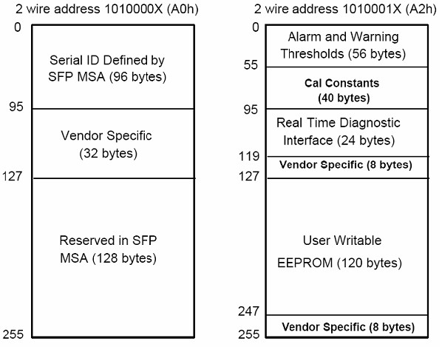

Table 2. EEPROM Serial ID Memory Contents(A0h)
Data Address | Length  (Byte) | Name of  Length | Description and Contents
Base ID Fields
0 | 1 | Identifier | Type of Serial transceiver (03h=SFP)
1 | 1 | Reserved | Extended identifier of type serial transceiver (04h)
2 | 1 | Connector | Code of optical connector type (07=LC)
3-10 | 8 | Transceiver | SONET
11 | 1 | Encoding | SONET Scrambled
12 | 1 | BR,Nominal | Nominal baud rate, unit of 100Mbps
13 | 1 | Reserved | (0000h)
14 | 1 | Length(9um,km) | Link length supported for 9/125um fiber, units of km
15 | 1 | Length(9um) | Link length supported for 9/125um fiber, units of 100m
16 | 1 | Length(50um) | Link length supported for 50/125um fiber, units of 10m
17 | 1 | Length(62.5um) | Link length supported for 62.5/125um fiber, units of 10m
18 | 1 | Length(Copper) | Link length supported for copper, units of meters
19 | 1 | Reserved
20-35 | 16 | Vendor Name | SFP vendor name:
36 | 1 | Reserved
37-39 | 3 | Vendor OUI | SFP transceiver vendor OUI ID
40-55 | 16 | Vendor PN | Part Number: “GL-xxxxx” (ASCII)
56-59 | 4 | Vendor rev | Revision level for part number
60-61 | 2 | Wavelength | Laser wavelength
62 | 1 | Reserved
63 | 1 | CCID | Least significant byte of sum of data in address 0-62
Extended ID Fields
64-65 | 2 | Option | Indicates which optical SFP signals are implemented(001Ah = LOS, TX_FAULT, TX_DISABLE all supported)
66 | 1 | BR, max | Upper bit rate margin, units of %
67 | 1 | BR, min | Lower bit rate margin, units of %
68-83 | 16 | Vendor SN | Serial number (ASCII)
84-91 | 8 | Date code | Manufacturing date code
92 | 1 | Diagnostic Type | Diagnostics
93 | 1 | Enhanced Options | Diagnostics
94 | 1 | SFF-8472 | Diagnostics
95 | 1 | CCEX | Check code for the extended ID Fields (addresses 64 to 94)
Vendor Specific ID Fields
96-127 | 32 | Readable | Vendor specific date, read only
128-255 | 128 | Reserved | Reserved for SFF-8079

- Digital Diagnostic Monitor Characteristics
Data Address | Parameter | Accuracy | Unit | Calibraton
96-97 | Transceiver Internal Temperature | ±3.0 | °C | internal
98-99 | VCC3 Internal Supply Voltage | ±5.0 | % | internal
100-101 | Laser Bias Current | ±10 | % | internal
102-103 | Tx Output Power | ±3.0 | dBm | internal
104-105 | Rx Input Power | ±3.0 | dBm | internal

- Regulatory Compliance
The transceiver complies with international Electromagnetic Compatibility (EMC) and international safety requirements and standards (see details in Table following).

Electrostatic Discharge  (ESD) to the Electrical Pins | MIL-STD-883E  Method 3015.7 | Class 1(>1000 V)
Electrostatic Discharge (ESD)  to the Duplex LC Receptacle | IEC 61000-4-2  GR-1089-CORE | Compatible with standards
Electromagnetic  Interference (EMI) | FCC Part 15 Class B  EN55022 Class B (CISPR 22B)  VCCI Class B | Compatible with standards
Laser Eye Safety | FDA 21CFR 1040.10 and 1040.11  EN60950, EN (IEC) 60825-1,2 | Compatible with Class 1 laser product.

- Reference
  - Small Form-factor Pluggable (SFP) Transceiver Multi-source Agreement (MSA) September 14, 2000.
  - Bellcore GR-253 and ITU-T G.957 Specifications.

- Recommended circuit & Mechanical Dimensions

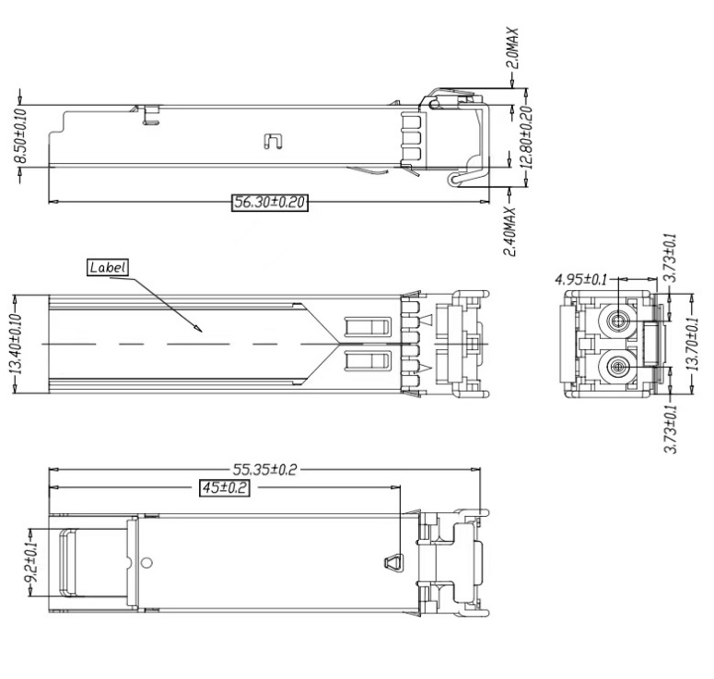

SFP Host Recommended Circuit Mechanical Drawing

Shenzhen GLight Communication Technology Co., Ltd.
Building 3, ChaoHuiLou Technology Industrial Park, No.119 Huating Road,
Dalang Sub-district, Longhua District, Shenzhen, China

GLIGHT reserves the right to make changes to the products or information contained herein without notice.
No liability is assumed as a result of their use or application.
No rights under any patent accompany the sale of any such products or information.

Published by Shenzhen GLight Communication Technology Co., Ltd. Copyright © GLight Communication Technology Co., Ltd. All Rights Reserved.

